Code normalisation and obsufication

Intro
As of today, most Anti-virus engines use two main methods to detect and decide if an executable is malicious or not. Those two methods are Detection of malicious data blocks (either strings or code blocks) and Heuristics’ based detection of malicious actions. Using those two methods, most Anti-virus engine manage to detect most “in the wild” viruses, either previously detected un-signed viruses and newly created/never discovered viruses.

Malicious Block Detection
A known technique in which the Anti-virus engine searches in an executable for strings or data blocks which are “signed” and known to the Anti-virus company as malicious. In fact, most Anti-virus Engines keep a Database of virus signatures. Those blocks can be part of a string which was detected in a common virus, Cryptographic keys known to be part of an attack, shellcodes and more. When the executable is created on disk (and sometimes, when it’s loaded into memory by a new process), the AV engine will scan it – sometimes pre-running and sometimes mid-execution. If the executable contains those signed blocks, the AV engine will detect it and declare it malicious.
For example, I wrote a simple WinAPI program, which detects what language is currently in use in the computer.

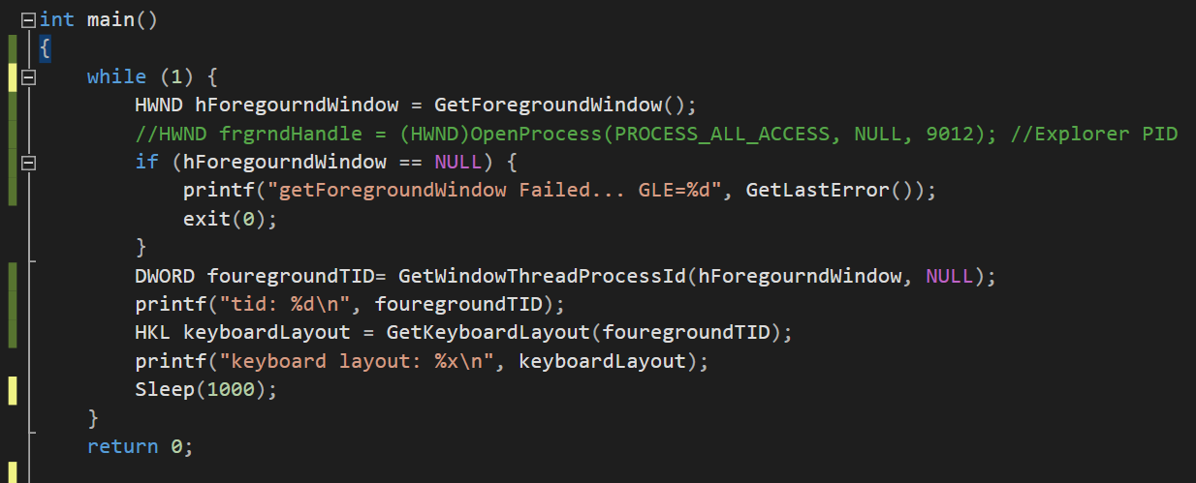
Obviously, this project is NOT malicious, and is using methods which every user may and might use. And when will check it against most Anti-virus engines out there, we will see that indeed most of them will not detect this program as malicious (only 4 out of 68 programs will detect this program).

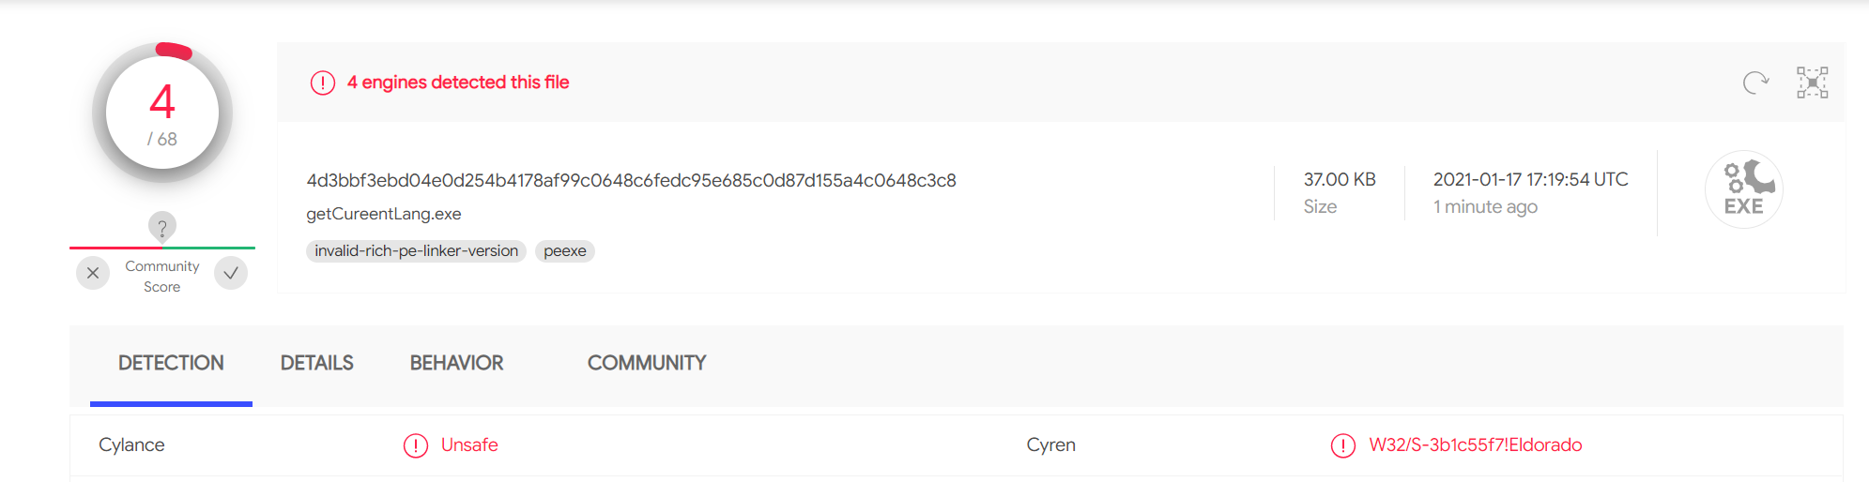

Now, we will edit our project, without changing it’s behavior, and we’ll add a few strings. Those strings are taken from known attack oriented tools published on github, for example from the Metasploit project (a Post-Explotation tool built for attackers and red-teamers alike), Impacket (a project built for letheral movement and Windows-Domain attacks) and Mimikatz (a tool built for grabbing windows password from a computer).

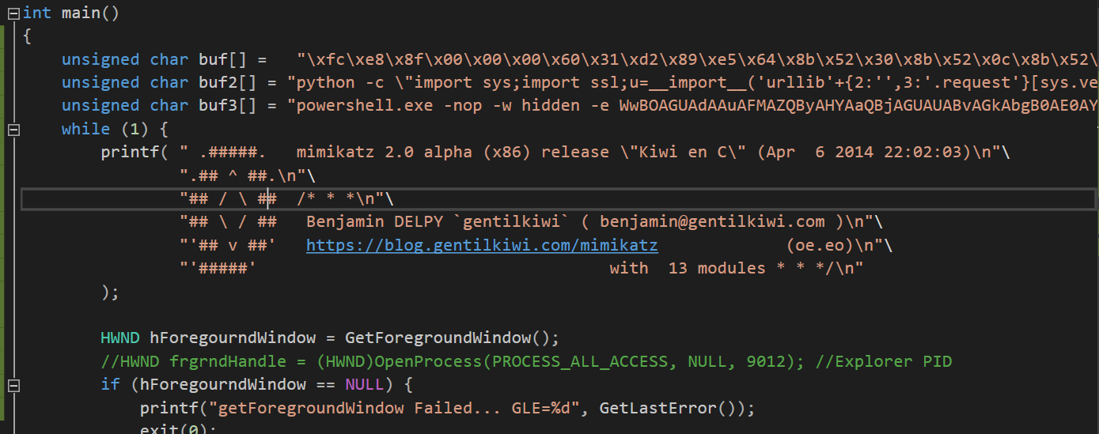

Now, after adding those “malicious” strings (please note that our project’s behavior and actions did not change), we’ll check our program again against most Anti-virus engines, and we’ll see that now, many more engines detect our program as malicious, including many “Big Players” in the industry that hold a big share of the market in the likes of Windows Defender, Cyberreason FireEye and more.
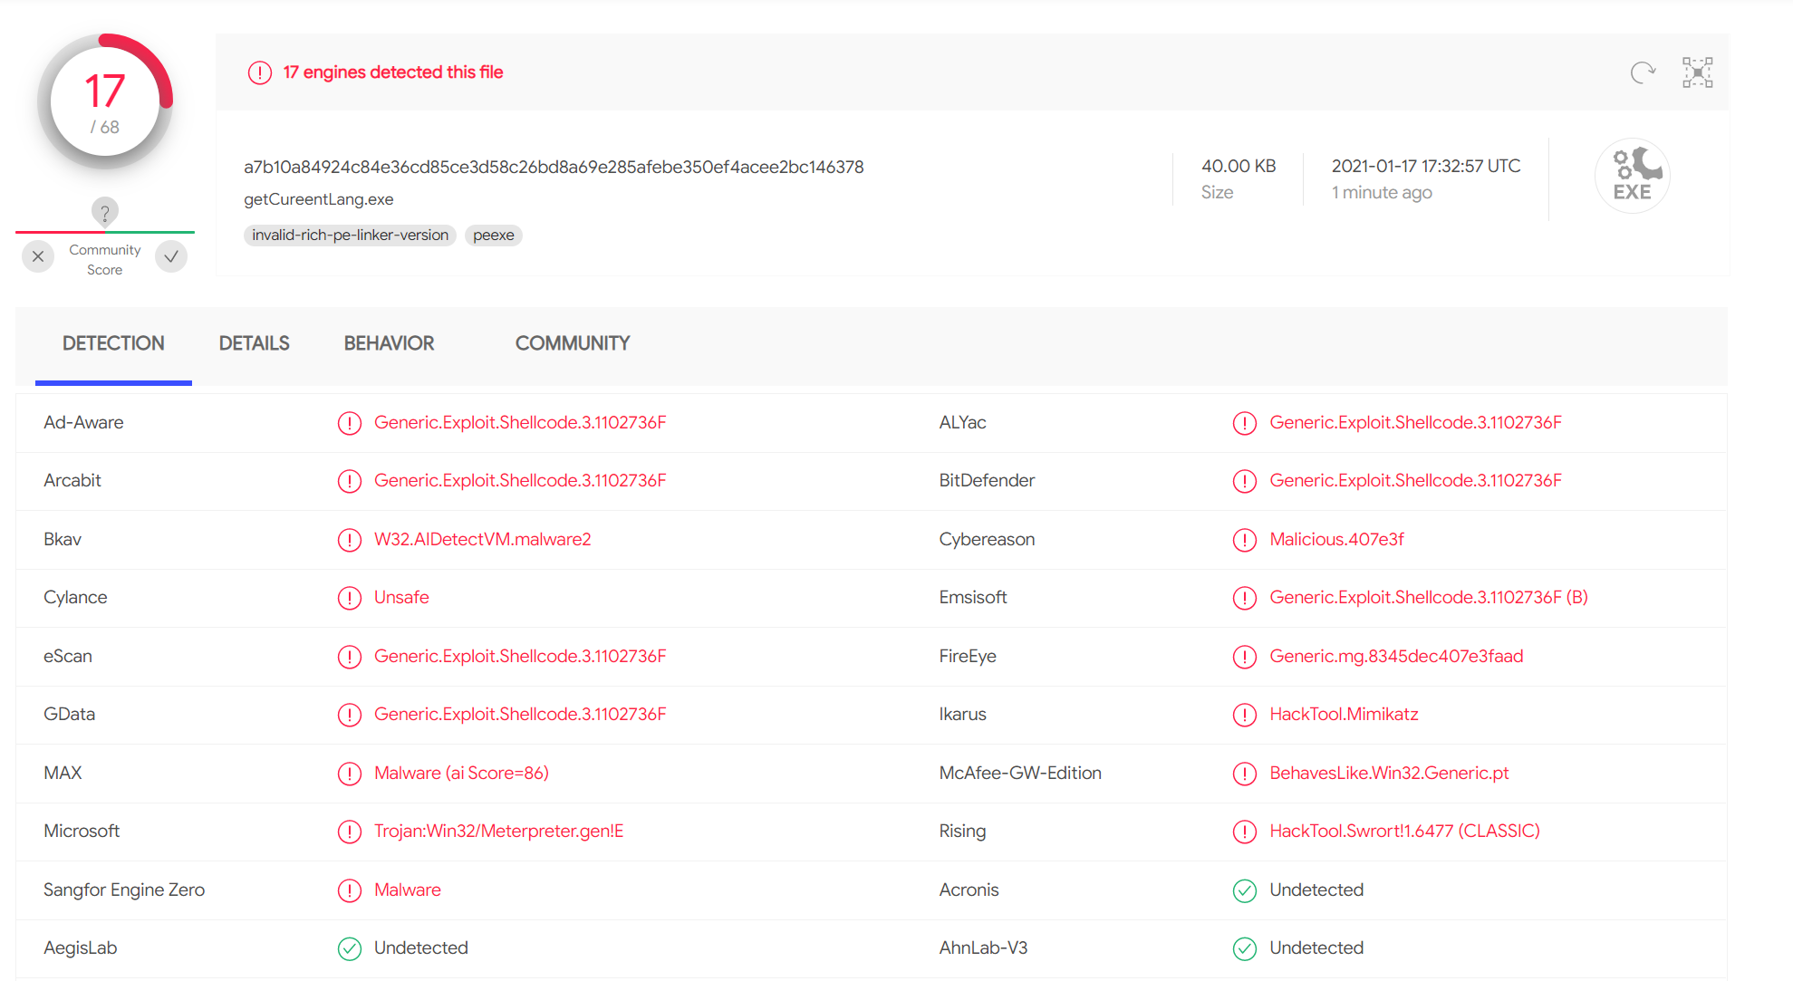

Heuristics’ based detection of malicious actions
Another method which most Anti-virus engines are using is Heuristics’ based search of action which the Anti-virus company defined might be malicious. Those actions were defined as potentially malicious by detecting similar behavior in many known attack and viruses, and most time those actions are needed in order to complete the full chain of attack on a computer/network (and example for which will be shown in later on). This search for behavior is more effective than searching for signed blocks, because it isn’t based on a specific data (URL’s, keys etc…) an attacker might change as he pleases, but is based on a set of actions which an attacker must perform in order to execute his malicious code/attack.
As an example, we will create a project that performs a classic DLL Injetion. It is important to note – in this project we did not use any blocks/strings that are connected to a known attack/project. Therefore, if our project will be detected as malicious – it will be detected by its behavior.
To perform a DLL Injection, we will create a Handle to another process (in this instance – notepad.exe). Then we will allocate space in the remote process’ address space and write the path to our dll there in order to dynamically load it. Then we’ll search for LoadLibrary address and create a remote thread that loads our library.
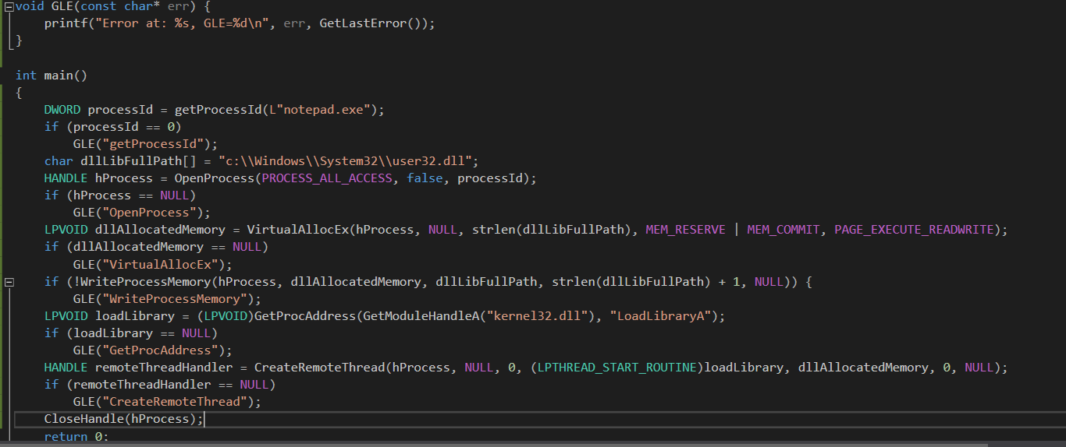

Now we’ll look how many Engines detect our program as malicious. And indeed, many engines detected our program.

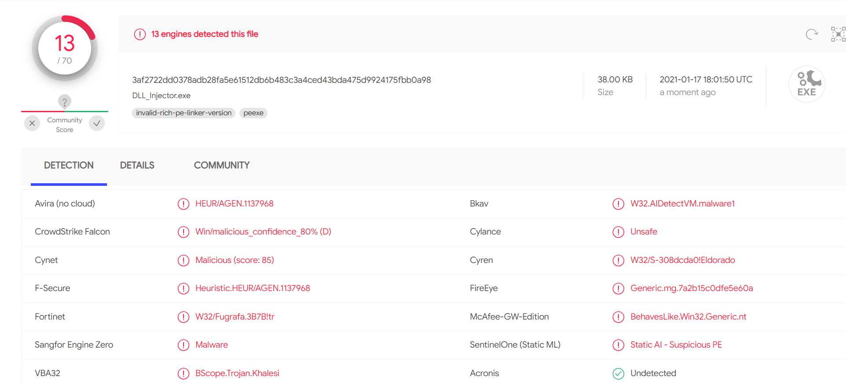

It is interesting to note that when we added a few calls to Sleep, the number of Anti-virus engines that detected our program was lowered, but not majorly enough.

